***Outcome***

***Shape***

***Cone***

***Cube***

***Sphere***

***Prism***

***Option 4***

***Option 3***

***Option 2***

design #4

***Option 1***

***Eye***

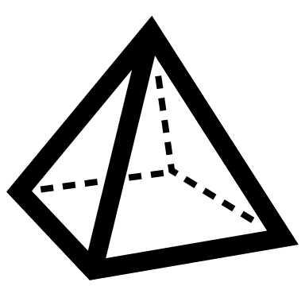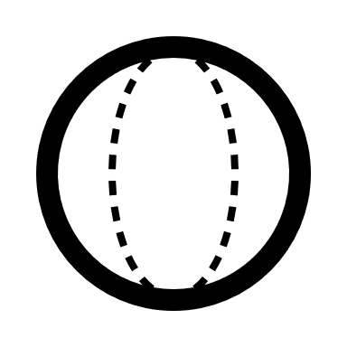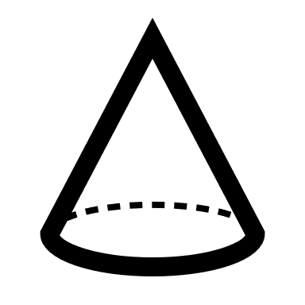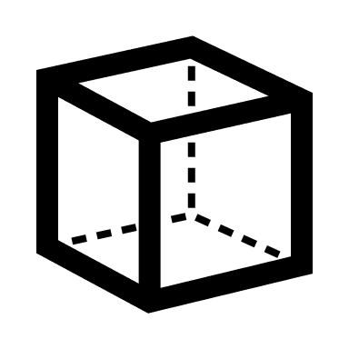

***Number of eyes***

**4**

**3**

**2**

**1**

***Eye type***

***Electrochemical eye***

***LEDS***

***Bionic eye***

***Prosthetic eye***

**One-Plastic-sphere-LED eye is considered to be efficient, economical, plain shape and applicable. However using 2 eyes it might sound more applicable but actually it’s more aesthetic**.

***Material***

***Plastic***

***Cork***

***Glass***

***Aluminum***